PRL welcomes its new communications coordinator, Igor Houwat. Igor will be responsible for telling the stories of the PRL and conveying ongoing research in an effort to inform the scientific and general publics on the latest discoveries and events emanating from the 12 resident labs and the MSU community more broadly. He’ll also strengthen and maintain relations with alumni in a program that is now 50 years old and boasts a strong relationship with the Department of Energy. He will additionally manage the PRL website content and design.

Igor, who hails from Brazil and Lebanon, is a Michigan State University alumnus with two MAs in Saxophone Performance and Ethnomusicology. He obtained a BA in Marketing from Ferris State University and has worked at local communications firm, MessageMakers. When not at the office, he’s either spending time with his lovely girlfriend, Lauren, talking with his mom and sister from Lebanon, practicing his Kung Fu moves, reading, hiking, and when time allows, teaching himself mandarin.

Igor is looking forward to collaborating with the faculty and students, crafting communications and strategies, and he is very excited to learn about the research!

To get in touch with Igor (link to profile page), call 517.353.2223 or email [houwatig@msu.edu](mailto:houwatig@msu.edu). Or, alternatively, he locks himself in his office and practices the oud (Middle Eastern lute) at lunch hour; guaranteed he’ll be there.

THUMBNAIL PIC:

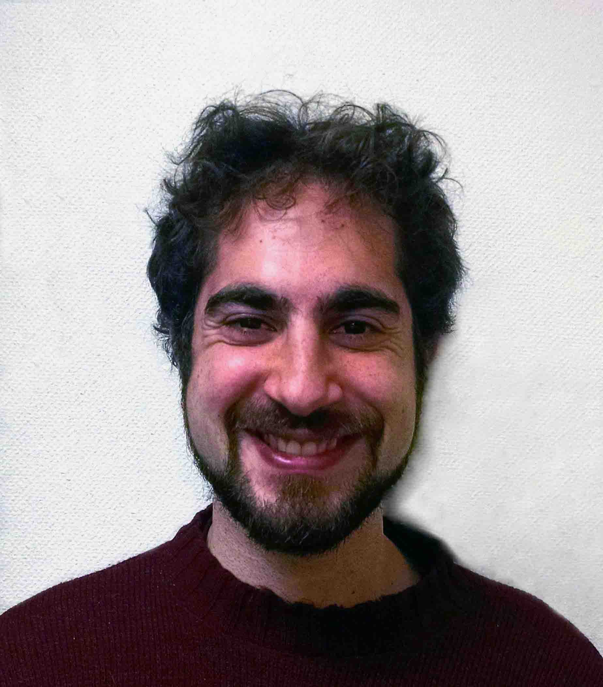

PIC IN STORY: (AKA: WHAT THE HECK IS AN OUD?) TEMPORARY PIC: 